Analysis

Login: The user will be presented with a welcome message and the options to either log in or exit the program. If the user chooses the login, they will have to enter a username and password, otherwise the they will be taken to the branch staff menus and system admin. If the password is incorrect, the user will be prompted to try again. If quit is selected, the program will end.

Branch Staff Menu: Once logged in, the user will be given the option of choosing from managing clients and accounts, exiting the program, or changing the password. If the user selects to change the password, then the change password option opens up, if the user chooses to open the client and management tab, they will be directed to the client and management menu.

System Admin Menu: Once the user successfully logs in as a system admin, the user will be prompted to choose from the options of managing clients and accounts, adding a branch staff member, deleting a branch staff member, displaying the branch staff, changing the password, or exiting the program. If the user selects the choice of client and account management, the user will be directed to the client and account management option. If the user chooses to change the password, the user will be prompted for a new password and the password will be changed if the password is valid. If the user chooses to add a branch staff member, the user is prompted to enter a user name, password, and specify the role of the staff member. If the user chooses to delete a branch staffer, the user will be prompted for the username of the user to be deleted. If the user chooses to confirm the deletion, the user is deleted. If the username entered is not found the user is given a warning and no user is deleted. If the user chooses to display the branch staff, the members within the system will be displayed. If the user chooses to exit, the program ends.

Client and Account Management Menu: Once the user is directed to the menu, the user will be prompted to choose to add a client, add an account, edit client information, manage an account, save client and account information, and exit the program. If the user chooses the valid option of adding a client, the user will be prompted to enter the name, address, social security number, employer, and annual income of the client. The new client is then added. If the user chooses to add an account, the user is prompted to choose a client. If the client entered is valid the user will be prompted to enter the account number, type, and balance. If the client entered is invalid, the user will be given an error and the user is prompted again. If the user chooses to edit client information, the user will be prompted to enter a valid client. That client’s information will then be displayed, and the user will be asked to confirm to update the information. The user will then be prompted new information for the client. The user will be prompted to choose between deposit, withdraw, and cancel. If the user chooses to withdraw or deposit, the user is prompted to enter the amount. The amount is then withdrawn or deposited into the account.

Design

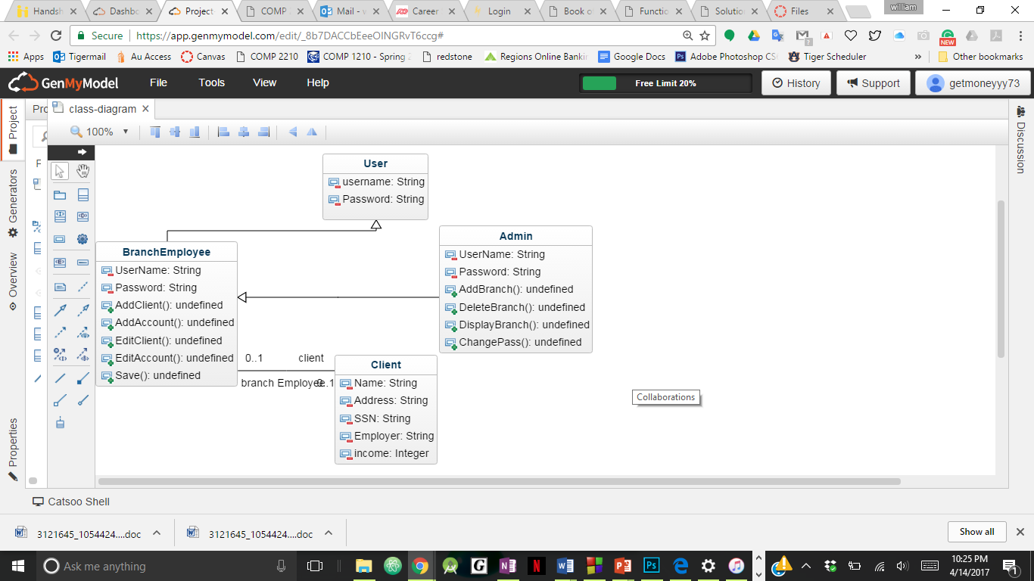

Testing

Test 1: The first test will test to make sure that the login prompt works and that the user can enter the password and username.

Test 2: The second test will be to test the function of logging into the branch staff menu.

Test 3: The third test is aimed to make sure the option menu works properly and that the proper numbers are entered, such as 1-6.